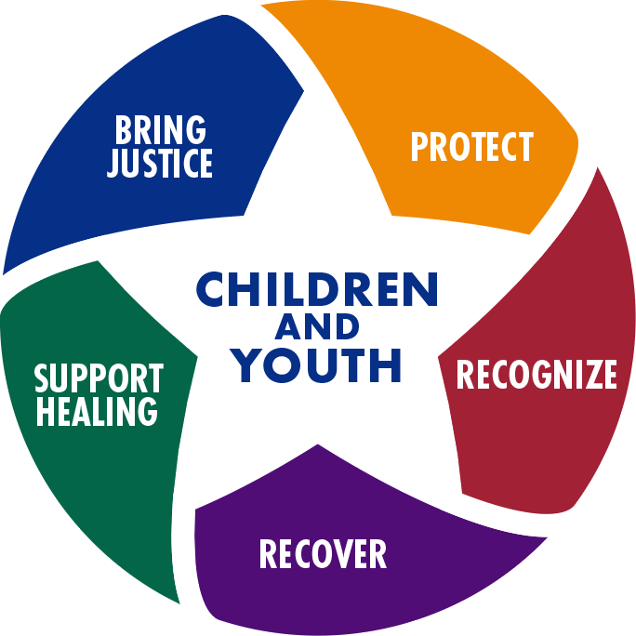

Thursday, February 5, 2026

8:00 a.m. to 3:30 p.m.
Commercial Sexual Exploitation Identification Tool (CSE-IT) Training for Law Enforcement & Criminal Justice Personnel

What is the CSE-IT? WestCoast Children’s Clinic’s Commercial Sexual Exploitation-Identification Tool (CSE-IT, pronounced “see it”) is a validated screening tool that helps identify children who are commercially sexually exploited (CSE). The CSE-IT is appropriate for use by any provider serving youth, including child welfare workers, probation officers, mental health clinicians, and first responders. The CSE-IT is designed to improve early identification of children and youth who are at high risk of experiencing or may be experiencing commercial sexual exploitation (CSEC) and human trafficking.
Why is CSE-IT training important for law enforcement and criminal justice personnel? Law enforcement officers and criminal justice personnel often encounter vulnerable and at-risk children and youth when carrying out their duties. CSE-IT training will help equip law enforcement officers and criminal justice personnel with information they can use to more effectively identify children who may be experiencing commercial sexual exploitation.
Who should attend this training? Anyone who works in the criminal justice field, particularly those who work with children and youth.

This CSE-IT Training will:
- Enable law enforcement and criminal justice personnel to accurately identify indicators of child sexual exploitation, without relying solely on youth self-disclosure, alerting the need for investigation, and
- Provide a framework of language and
understanding that will improve their communication with service providers and partners doing collaborative work
in human trafficking prevention and identification. Attendees will receive instruction on:
- How to use and score the CSE-IT screening tool.
- The importance of a victim-centered approach when dealing with victims of human trafficking.
- How victims of human trafficking are groomed by
traffickers.
- How trauma and repeated trauma impacts the brain.


Eligible for TCOLE credit hours
Register @ www.gusgeorgelawenforcementacademy.org

Jessie.Agee-Balaszi@fbctx.gov
281-238-1583

